The Mathematics of Sound and the Search for Negative Peaks
CliDeck Research Notes · Bass Plus · 18 October 2026

Abstract
How far below its average must a collection of synchronized waves fall? This question leads from a simple model of sound to Chowla’s cosine problem, a difficult question about sums of distinct integer frequencies. This report brings together a sequence of ninety exploratory approaches, their mathematical checks, and their limitations. It develops exact examples, a spectral interpretation, a counterexample to minimum detection by a natural sampling grid, and an explicit approximation bound whose sufficient polynomial degree depends on the number of frequencies and the requested error, but not on the largest frequency. The approximation method belongs to Lasserre’s established pushforward measure hierarchy; its Chebyshev filtering mechanism is closely related to work of Slot and Laurent. We claim neither a solution of Chowla’s conjecture nor priority for this general method. The useful outcome is a reproducible account of what can be proved, what finite computations show, and which tempting extensions fail. Eight figures connect the analysis to phase locking, sampling, weighted amplitudes, spectral bands, and finite searches.

1. The question behind the waves
Take a finite set of distinct positive integers $A$, and let $N=\left|A\right|$. We study the real function
fAx=a∈A​cosax, x∈0,2π.
Every component has amplitude one. Every initial phase is zero. There is one common variable $x$: the components cannot choose their phases independently. Define the depth of the most negative excursion by
$$K\left(A\right)=−\min_{x∈\left[0,2π\right]}f_{A}\left(x\right).$$
Chowla’s question asks whether there is an absolute constant $c>0$ such that
$$K\left(A\right)≥c\sqrt{N}$$
for every such set $A$. The constant would have to work for consecutive frequencies, sparse frequencies, sets with strong arithmetic relations, and arbitrarily large frequency values. There is no upper bound on $maxA$ in the question. Recent papers make substantial progress on weaker polynomial lower bounds, but the sources consulted for this report continue to distinguish that progress from the square-root target. [JMTZ2025] [Bedert2026] [Shankar2026]
The quantifiers are the heart of the problem. Finding a large negative excursion for a particular set is valuable, but proving it for every finite set is a different task. Replacing $c$ by the set-dependent number $c\left(A\right)=K\left(A\right)/\sqrt{N}$ is an exact description, not a resolution: one must still prove that the infimum of this function stays positive over all sets and all sizes.
For a sound interpretation, set $x=2πν_{0}t$, where $ν_{0}$ is a base frequency in hertz. Then the physical frequencies are $aν_{0}$. The mathematical model describes an ideal harmonic signal with equal amplitudes and synchronized phases. Music and equalized audio usually have unequal amplitudes, changing phases, noise, and finite observation windows. The model helps explain interference and measurement; it does not, by itself, establish a benefit of an audio product.

2. What the coefficient means physically
Use normalized averaging over a full period:
$$E\left[g\right]=\frac{1}{2π}\int_{0}^{2π}{g}\left(x\right) dx.$$
Orthogonality gives $E\left[f_{A}\right]=0$ and $E\left[f_{A}^{2}\right]=N/2$. Thus the root-mean-square amplitude is $\sqrt{N/2}$, while $f_{A}\left(0\right)=N$. All signals in this model have the same RMS amplitude when they have the same number of frequencies. Their negative peaks can nevertheless differ.
For example,
$$K\left(\{1,2\}\right)=\frac{9}{8}, K\left(\{1,3\}\right)=2.$$
For the first set, put $u=cosx$ and complete the square:
$$cosx+cos2x=2{\left(u+\frac{1}{4}\right)}^{2}−\frac{9}{8}.$$
For the second, both cosines equal $−1$ at $x=π$. The first signal has a shallower trough despite identical RMS amplitude. The dimensionless negative crest factor is
$${CF}_{−}\left(A\right)=\frac{K\left(A\right)}{\sqrt{N/2}}=\sqrt{2} \frac{K\left(A\right)}{\sqrt{N}}.$$
This explains the normalization: $c$ would be a uniform lower bound on a normalized negative peak. It is not an energy quantum, a material constant, or a new universal constant of physics.
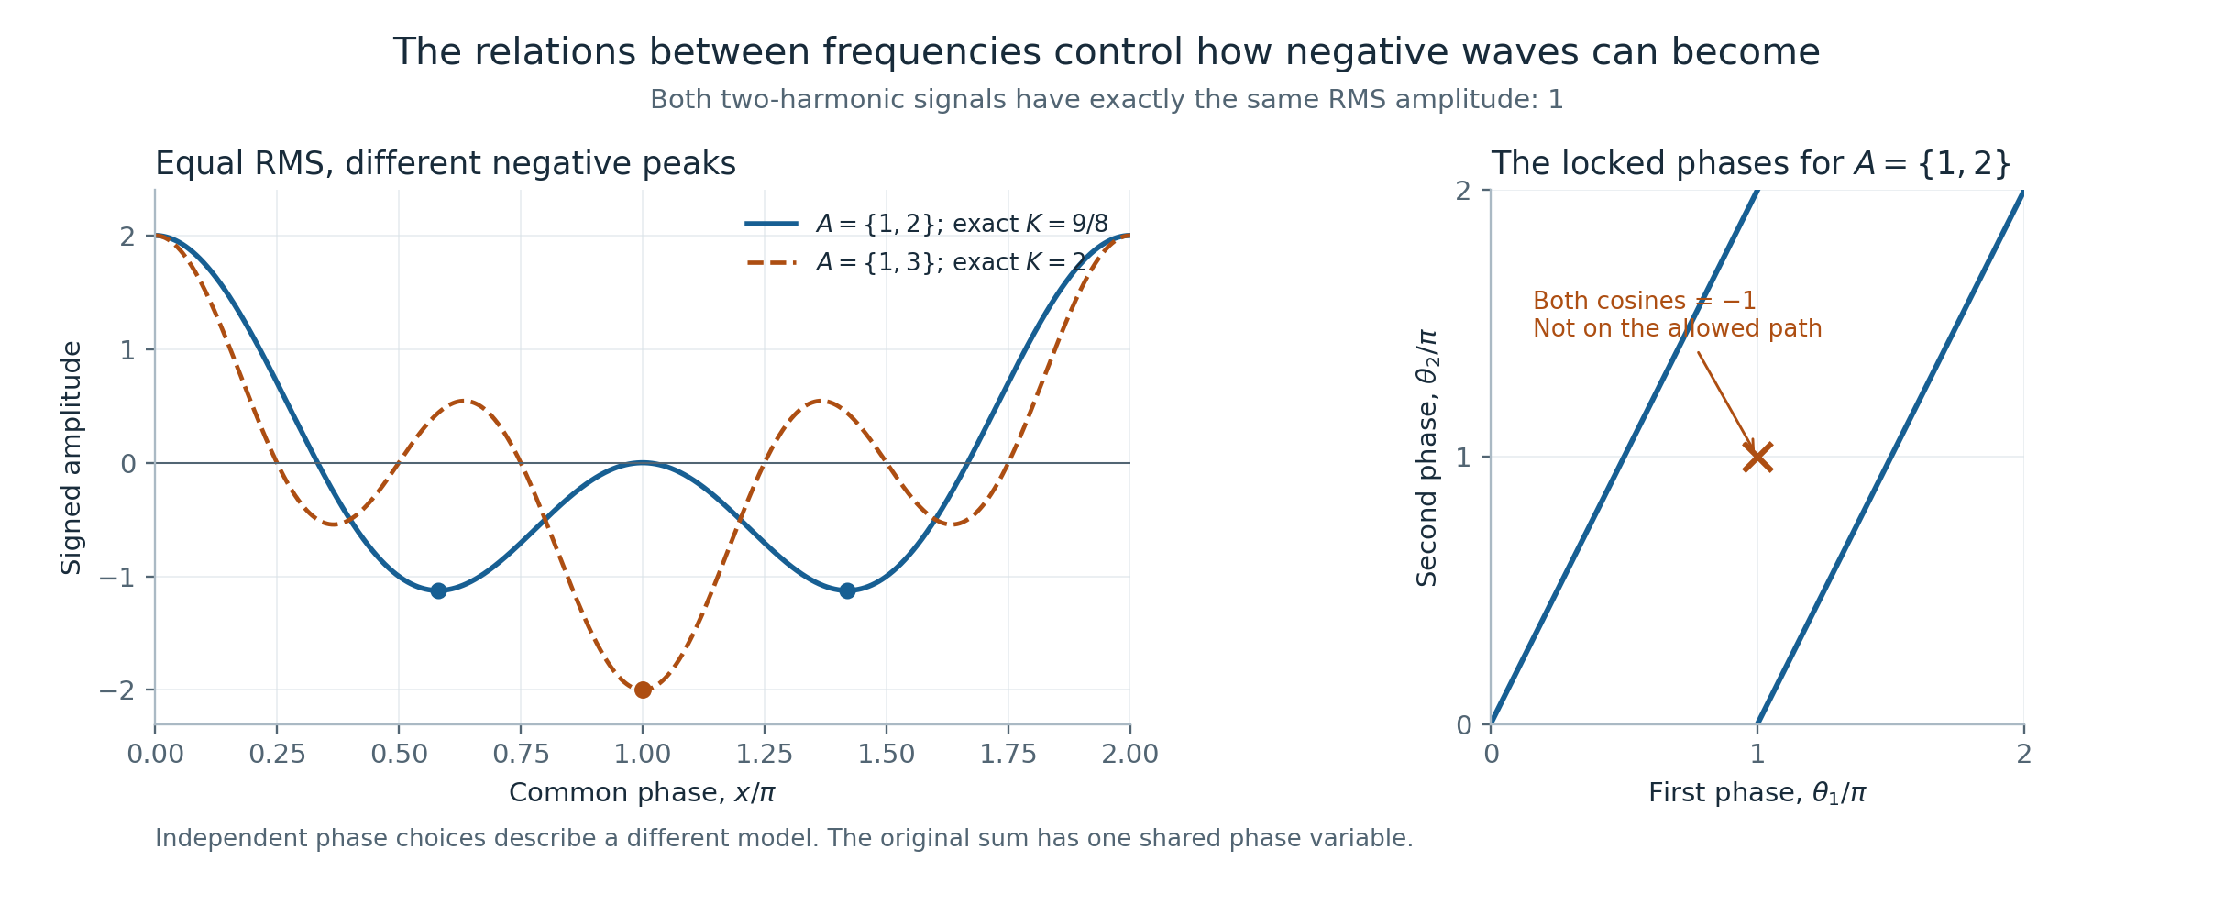
Figure 1. Phase locking changes the attainable trough. The two signals have equal RMS amplitude. For $A=\{1,2\}$, the hypothetical independent-phase value $−2$ is inaccessible; the exact common-phase minimum is $−9/8$. The chart keeps the hypothetical model explicitly separate from the actual signal.
If $f_{A}$ represents acoustic pressure relative to equilibrium, negative values describe rarefaction. They do not mean negative acoustic energy. In the plane progressive-wave approximation, average intensity is proportional to mean-square pressure, with proportionality determined by acoustic impedance. This physical distinction matters whenever a proposed proof replaces a signed wave amplitude by a squared magnitude. [BakerAcoustics]

3. Why a single common phase is restrictive
The vector $\left(cos\left(a_{1}x\right),…,cos\left(a_{N}x\right)\right)$ follows a one-parameter path. For multiple frequencies, it does not explore the entire cube ${\left[−1,1\right]}^{N}$. For $A=\{1,2\}$, the relation $cos2x=2\cos^{2}x−1$ prevents both coordinates from being $−1$ at once. Allowing separate phases removes that constraint and changes the problem.
The same point becomes geometric with three frequencies. The path
$$x↦\left(cosx,cos2x,cos3x\right)$$
is a curve inside a cube. Colouring each point by the sum of its coordinates shows exactly which signal values this shared clock can reach. A rotation of the display changes our viewpoint, not the set of attainable states. This is why a three-dimensional figure is useful here: its geometry represents an actual constraint.
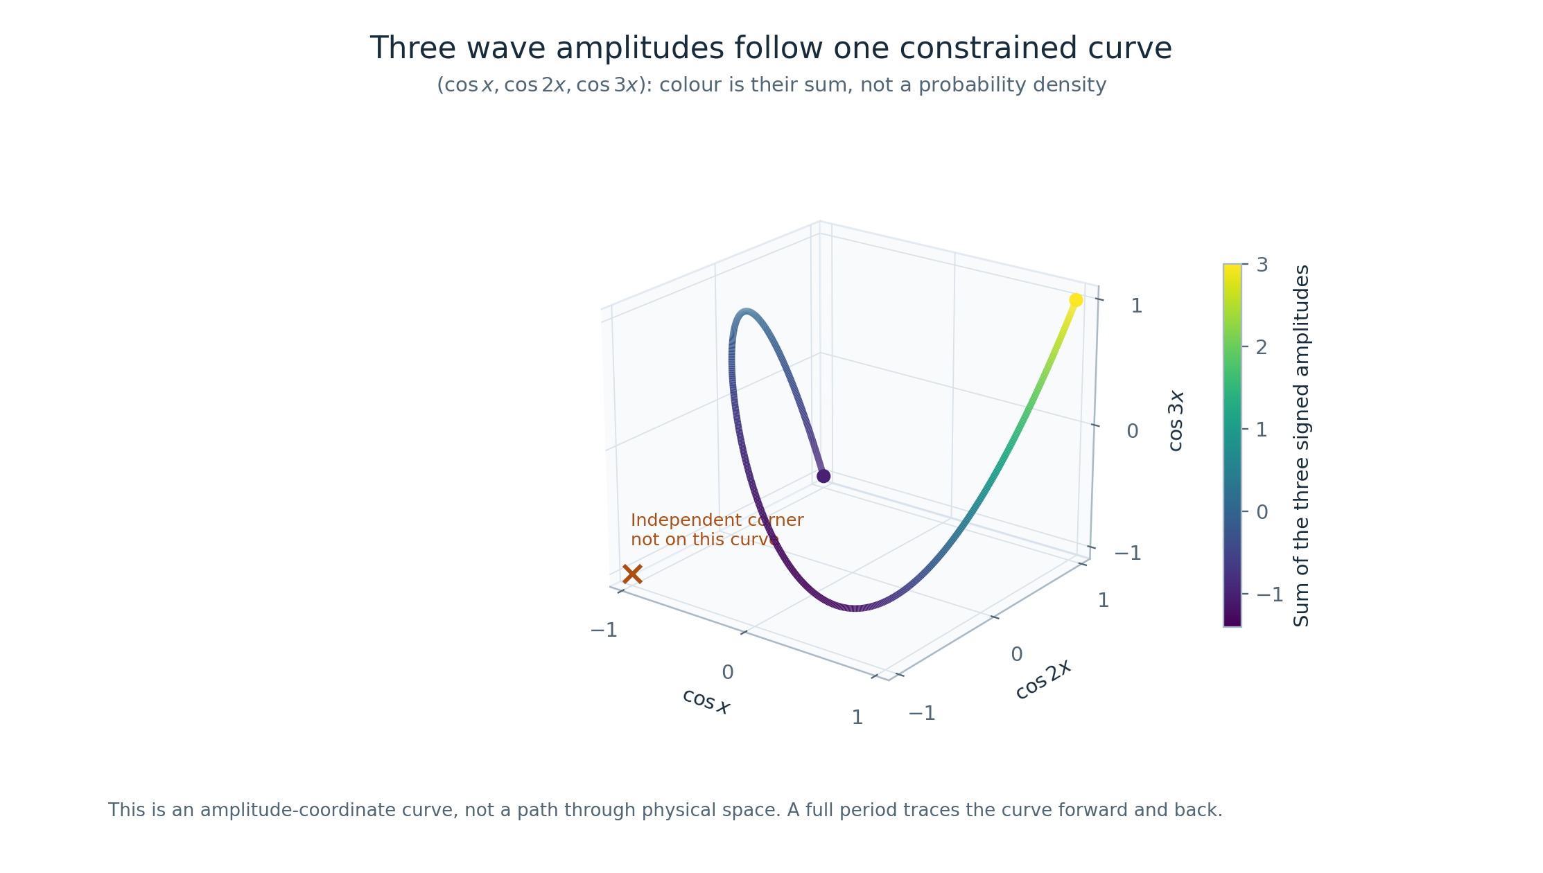
Figure 2. One clock traces a curve, not a cube. The colour is the actual sum $cosx+cos2x+cos3x$. The corner $\left(−1,−1,−1\right)$ is not on the curve. Over a full period, the real cosine-coordinate curve is retraced. The figure is a classical phase model, not a visualization of a quantum state.
Multiplying every frequency by the same positive integer $d$ has a different effect. Since $f_{dA}\left(x\right)=f_{A}\left(dx\right)$, it compresses the pattern in time while preserving its full-period range:
$$K\left(dA\right)=K\left(A\right).$$
A trough can become narrower in a local time window without becoming shallower. Any argument that estimates the total negative contribution from one local width must account for the increased number of repeated troughs.
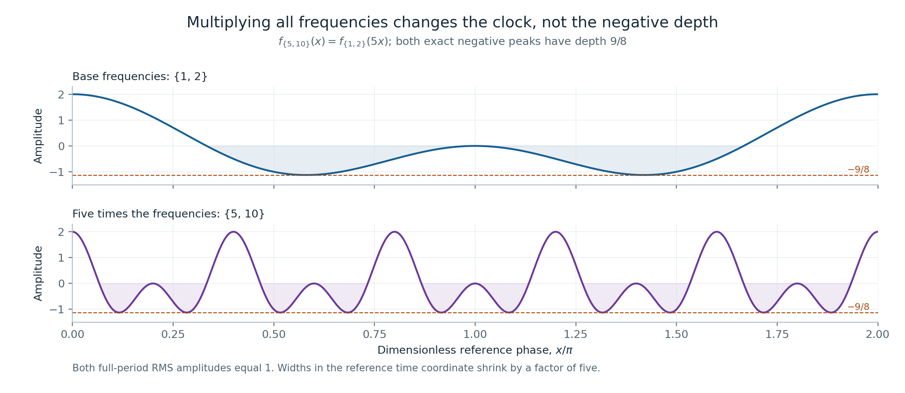
Figure 3. Frequency scale and peak depth are different quantities. The sets $\{1,2\}$ and $\{5,10\}$ both have $K=9/8$. Dilation produces more oscillations within the same displayed interval. It does not improve the normalized negative minimum.

4. A sampling grid can hide the trough
Consider $A=\{1,…,N\}$ and let $q=2N+1$. On the equally spaced grid $x_{j}=2πj/q$, a roots-of-unity identity gives
$$f_{A}\left(x_{0}\right)=N, f_{A}\left(x_{j}\right)=−\frac{1}{2} \left(1≤j<q\right).$$
The grid therefore reports a negative depth of only $1/2$. It also reports the correct mean-square value:
$$\frac{1}{q}\sum_{j=0}^{q−1}{f_{A}}{\left(x_{j}\right)}^{2}=\frac{N}{2}.$$
Yet at the point between grid locations $x=3π/q$, the Dirichlet-kernel identity yields
$$f_{A}\left(3π/q\right)=−\frac{1}{2}−\frac{1}{2sin\left(3π/\left(2q\right)\right)}.$$
Consequently,
$$K\left(A\right)≥\frac{1}{2}+\frac{q}{3π}.$$
The hidden excursion grows linearly with $N$. This is an exact family of counterexamples to using the smallest raw sample as the true minimum. It is not a failure of trigonometric interpolation: the same grid contains enough information to reconstruct this finite-bandwidth trigonometric polynomial. Reconstructing a signal and simply taking the smallest of its stored samples are different operations.
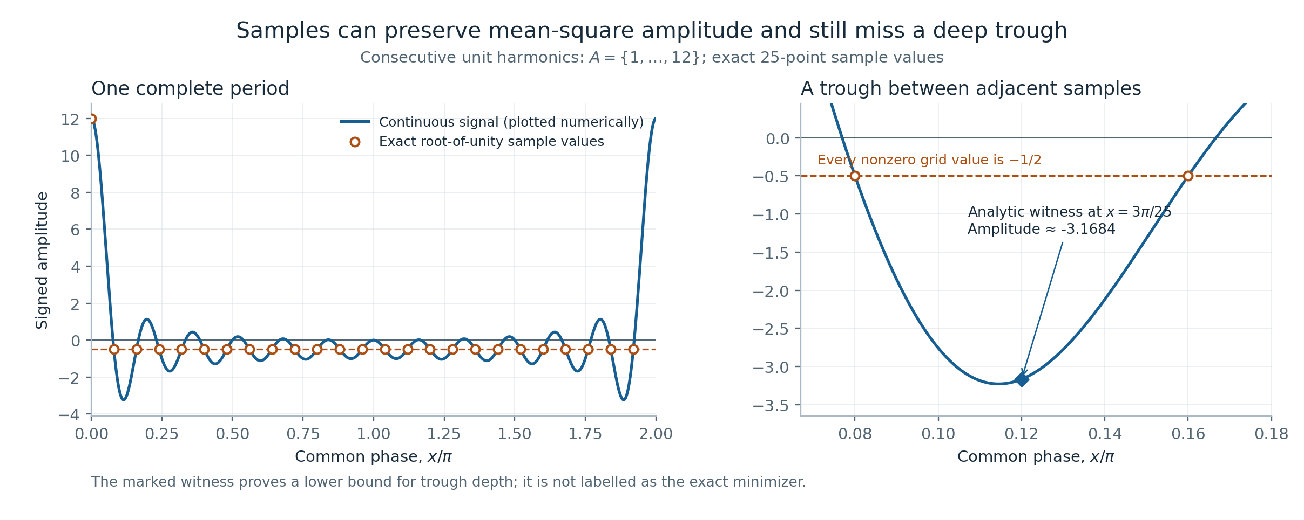
Figure 4. Correct RMS does not certify the minimum. For $N=12$ and $q=25$, every nonzero sample is $−1/2$, while the continuous curve passes much lower between samples. The highlighted off-grid point is an exact witness. The drawn smooth curve is an illustration, not a substitute for the identity.
A simple rigorous guard is available for a general set. For a grid with $M$ equally spaced points, let $K_{M}$ be minus the smallest sample. The derivative bound $\left|f_{A}′\right|≤∑a$ gives
KM≤KA≤KM+πMa∈A​a.
A second-derivative argument at a true minimum improves the error bound to $π^{2}∑a^{2}/\left(2M^{2}\right)$ when that is smaller. A scientific interactive chart should display the certified interval alongside the sampled value. A dense curve by itself does not supply a certificate.

5. The same function as a lattice spectrum
There is an exact way to reinterpret the cosine sum as a particle-like hopping model. Let $T$ be the bilateral shift on square-summable sequences indexed by the integers, and define
HA=12a∈A​Ta+T−a.
Fourier transformation turns each shift into a complex phase. The operator becomes multiplication by $f_{A}\left(x\right)$, so its spectrum is the full interval
$$σ\left(H_{A}\right)=\left[−K\left(A\right),N\right].$$
This is a mathematical identity. The wave minimum becomes the lower edge of the spectrum of a translation-invariant lattice operator. The model is related to tight-binding descriptions of hopping on a lattice. An infinite lattice can have continuous spectral bands even though its sites are discrete; discrete position labels alone do not quantize all possible energies. [TongAQM]
A finite ring introduces a boundary condition. With $q$ sites and a phase twist $ϕ$, its eigenvalues are
$$E_{j}\left(ϕ\right)=f_{A}​\left(\frac{2πj+ϕ}{q}\right), 0≤j<q.$$
At $ϕ=0$, the ring sees one sampling grid. As $ϕ$ varies through a full turn, the eigenvalue curves sweep the entire continuous phase variable. Taking the minimum over both $j$ and $ϕ$ recovers $−K\left(A\right)$ exactly. The boundary twist repairs this finite model’s missing phases; it does not create a new universal lower bound. Twisted boundary conditions are an established tool in spectral physics. [Bardyn2014]
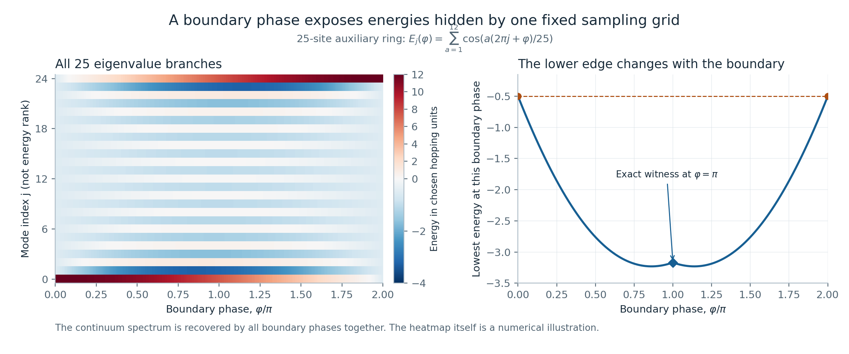
Figure 5. A boundary phase reveals what one finite ring misses. The heatmap shows the actual values $E_{j}\left(ϕ\right)$ for $q=25$ and $A=\{1,…,12\}$. The untwisted column has the exceptional two-value spectrum, while other twists expose lower energies. The vertical coordinate labels finite eigenvalue branches rather than an independent sound frequency.

6. A certified way to approximate each minimum
For a real polynomial $p$ of degree at most $d$, consider the weighted average
$$R\left(p\right)=−\frac{E\left[f_{A}p{\left(f_{A}\right)}^{2}\right]}{E\left[p{\left(f_{A}\right)}^{2}\right]}.$$
The denominator is positive for nonzero $p$ because $f_{A}$ is nonconstant and its range contains an interval. The nonnegative weight $p{\left(f_{A}\right)}^{2}$ cannot produce an average below the true minimum. Hence $R\left(p\right)≤K\left(A\right)$. Optimizing over the polynomial gives
$$B_{d}\left(A\right)=\max_{0≠p, degp≤d}R\left(p\right)≤K\left(A\right).$$
These lower estimates of the depth increase with $d$. They can be expressed as a generalized eigenvalue problem in moments $μ_{k}=E\left[f_{A}^{k}\right]$. The sign convention matters: the corresponding estimate of $minf_{A}$ is an upper bound, while its negative is a lower bound on $K\left(A\right)$.
This is the pushforward measure hierarchy developed by Lasserre, specialized to the distribution of a cosine sum. Permitting a sum of polynomial squares instead of one square gives the same optimal quotient: the quotient for a sum is a weighted average of the individual quotients. The construction and its basic convergence are established prior work. [Lasserre2021]
The report provides an explicit sufficient degree tailored to the present family. For $0<ε≤N$, set
$$M=\left\lceil \frac{8πN}{ε}\right\rceil .$$
Then the mathematical appendix proves that
$$d≥\left\lceil \sqrt{\frac{N}{ε}}\left[NlogM+log​\left(\frac{16N}{ε}\right)\right]\right\rceil ⇒ 0≤K\left(A\right)−B_{d}\left(A\right)≤ε.$$
The logarithm is natural. The sufficient degree depends on $N$ and the requested absolute error, but not on $maxA$. The proof first shows that a set of phases close to a minimum has a uniform positive measure, using a partition of the phase torus. A Chebyshev polynomial then gives that region a sufficiently large relative weight. The underlying filtering architecture is closely related to the needle-polynomial analyses of Slot and Laurent. The frequency-independent specialization and its constants are proved here for review; their priority has not been established. [SlotLaurent2021] [SlotLaurent2022] [NISTDLMF]
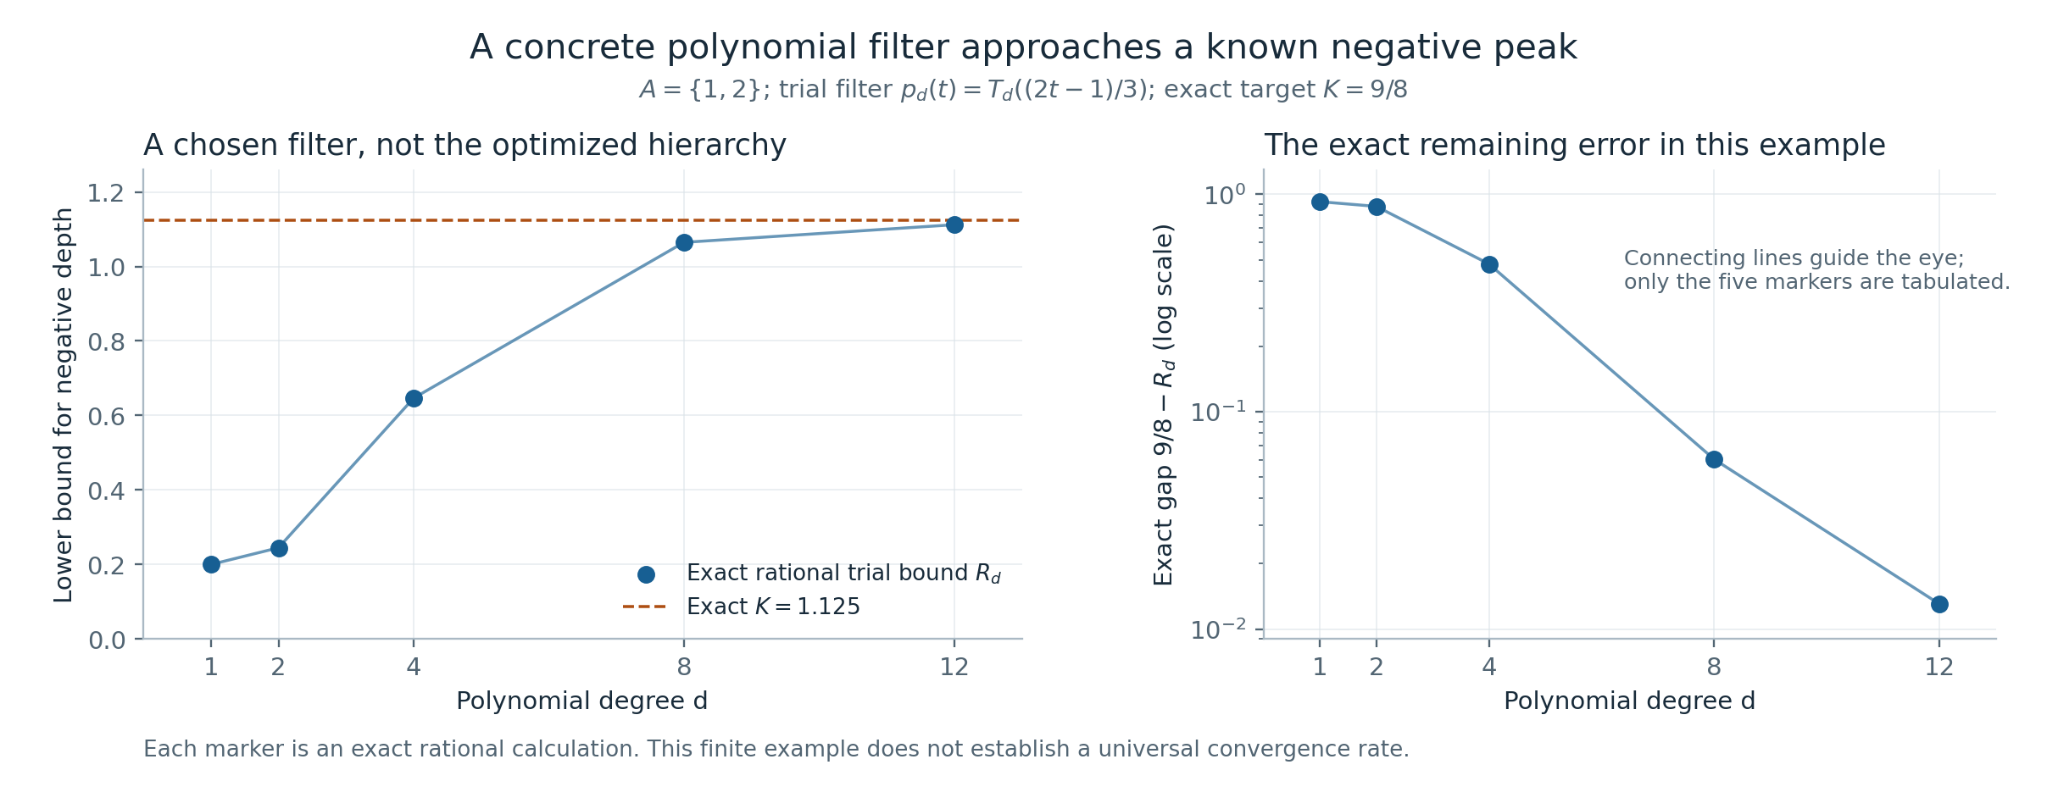
Figure 6. A valid approximation can improve without solving the conjecture. For $A=\{1,2\}$, an explicitly chosen Chebyshev trial polynomial gives exact rational values at the highlighted degrees, approaching the known depth $9/8$. These are values of a particular trial quotient $R_{d}$, not the optimized hierarchy $B_{d}$. The comparison line is an exact minimum in this special example.
This result answers an approximation question for each input. It does not answer the extremal question over all inputs. The degree may be large, exact moments may be expensive to compute, and a generalized eigenvalue calculated in floating point requires an error certificate before being called exact. A finite sufficient degree is not a claim of practical polynomial runtime in the input length.

7. Negative results that narrow the search
Some failed extensions have clean mathematical explanations. Their value is to prevent the same obstruction from being mistaken for progress again.

Unequal amplitudes change the theorem
For weights $w_{a}=1−a/\left(N+1\right)$ on $a=1,…,N$, the Fejér-kernel identity gives
$$\sum_{a=1}^{N}{w_{a}}cos\left(ax\right)=\frac{F_{N}\left(x\right)−1}{2}≥−\frac{1}{2},$$
and equality is attained. Meanwhile $∑w_{a}^{2}=N\left(2N+1\right)/\left(6\left(N+1\right)\right)$ grows linearly in $N$. Therefore the negative depth divided by the coefficient norm tends to zero. Multiplying by $N+1$ gives positive integer weights and the same failure after normalization. Making amplitudes integer-valued does not restore the unit-amplitude conjecture.
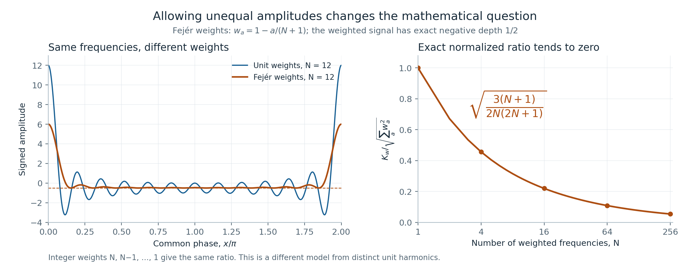
Figure 7. A sharp positive pulse can coexist with a fixed negative floor. Fejér weights give an exact depth of $1/2$ while the coefficient norm grows. The companion normalization plot explains why this is a counterexample to a weighted extension, not to Chowla’s original equal-amplitude problem.

A physically inspired weight can emphasize too little
The logistic or Fermi–Dirac-inspired weight $w_{β}\left(x\right)=1/\left(1+e^{βf_{A}\left(x\right)}\right)$, with $β≥0$ and threshold fixed at zero, defines a valid lower estimate
$$B_{β}=−\frac{E\left[f_{A}w_{β}\right]}{E\left[w_{β}\right]}.$$
For consecutive frequencies, the appendix proves $B_{β}≤20+10log\left(2N+1\right)$ for every $β$. Choosing a larger inverse-temperature parameter cannot turn this particular family into a square-root certificate on every input. An adjustable threshold would be a different family and is not ruled out by this statement.

A promising finite minimum remains finite evidence
Another nonnegative weight is the Riesz product a∈A​1−cosax. Its associated quotient can be calculated exactly from integer Laurent-polynomial coefficients. The recorded exhaustive calculation checks all $262,143$ nonempty subsets of $\{1,…,18\}$. On that finite domain, the smallest normalized quotient is $7/20$, attained at $A=\{1,2,3,4,5,7,9,11,13\}$.
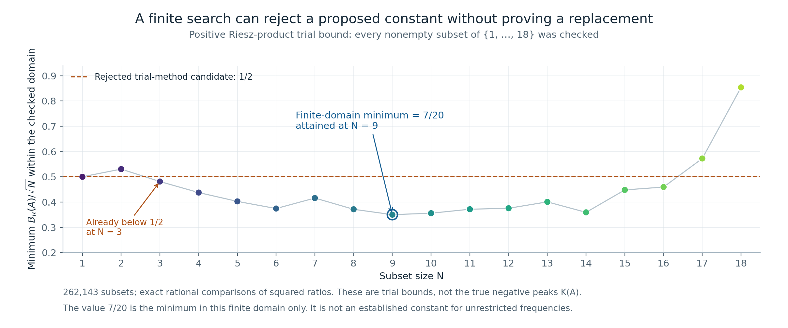
Figure 8. A finite search suggests questions; it does not settle all frequencies. The plotted minima are grouped by set size within the fixed universe $\{1,…,18\}$. The value $7/20$ is an exact finite-domain result. The rejected candidate $1/2$ fails already for $A=\{1,2,3\}$. No universal lower bound for this Riesz quotient is claimed.

8. What the quantum analogy contributes
The wave-to-lattice correspondence is useful because it is exact and preserves the quantity being studied. Other quantum analogies need an equally explicit dictionary. For a harmonic oscillator, a number state has zero mean displacement even when it has nonzero occupation. A coherent state can have a sinusoidal mean displacement, while its mean occupation need not be an integer. The integer spectrum of the number operator does not force the Fourier coefficients of a classical waveform to be integers. Squeezing changes quadrature variances; it need not change the mean waveform. [Cappellaro2012] [Shapiro6453]
Experiments can control individual mechanical quanta, so phonons are physical rather than merely metaphorical. That does not transfer a quantum measurement theorem to a signed classical cosine sum without proof. [OConnell2010] In this investigation, the productive question was not whether an analogy sounded surprising, but whether it preserved amplitudes, phases, averaging, and the minimum. The catalogue records where those requirements succeeded and where they failed.

9. Evidence, provenance, and the remaining problem
The companion mathematical appendix supplies full proofs and separates identities, inequalities, and finite examples. The research catalogue indexes ninety numbered approaches and an earlier unnumbered groundwork stage. The archive includes the preserved source notes, code, result files, and three sealed historical archives. It also identifies corrections that supersede earlier statements.
A selected reproduction of the early groundwork checked all $4,194,303$ nonempty subsets of $\{1,…,22\}$ with two different enumeration procedures. Both found the same unique minimizer of $K\left(A\right)/\sqrt{\left|A\right|}$ within that finite universe: $A=\{1,2,3,4,5,6,7,8,10,11,13,14,15,16,17,21\}$. Exact certificates put its depth strictly between $2.4548327530$ and $2.4548327531$. This concerns the actual continuous minimum; the separate Riesz calculation above concerns a particular lower-estimate method. Neither finite result covers arbitrarily large frequencies. The reproduction report and its machine-readable outputs are included in the archive.
There is a material provenance limitation: approaches 41–50 were reconstructed from surviving descriptions rather than recovered as original bytes. In particular, the earlier claim involving 1,980 finite certificates for approach 42 cannot be represented as a reproduced certificate set; those files are missing. A separately available tail argument has a different verification status. These distinctions are documented in the catalogue and provenance notes.
The checks in this project consist of mathematical derivations, exact arithmetic programs, independent calculations within this workflow, and reproducible numerical illustrations. They are not external peer review or formal proof-assistant verification. ChatGPT assisted the writing, derivations, literature comparison, and code preparation. No claim of independent verification by OpenAI is made.
What remains is precise: prove a positive universal lower bound for $K\left(A\right)/\sqrt{\left|A\right|}$, or produce a valid sequence of unit-amplitude, zero-phase, distinct positive integer frequency sets for which that ratio tends to zero. None of the weighted examples, finite grids, independent-phase models, or finite searches in this report accomplishes either task. The present contribution is a checked collection of tools and obstructions, with a clear route for readers to inspect and extend the work.

Further reading and supporting material
The accompanying pages are Sampling and Hidden Peaks, Waves and Lattice Particles, Certified Minimum Estimates, The Limits of Wave Analogies, Research Catalogue of Ninety Approaches, and the Mathematical Appendix. Full bibliographic entries appear on the References page. The downloadable research edition includes all of these texts and the reproducibility materials.

References and Literature Context
This bibliography supports the curated research report and its companion pages. Sources were checked on 18 October 2026. The descriptions identify why a reference is relevant; they do not claim an exhaustive priority search or an independent verification of every result in the cited literature. Attribution is provided through authors, titles, years, and publication identifiers, without outgoing website links. The cited external papers are not redistributed in this archive. Historical source notes retain their original form and are supplied as research records.

Chowla’s problem and recent progress

JMTZ2025
Zhihan Jin, Aleksa Milojević, István Tomon, and Shengtong Zhang. From small eigenvalues to large cuts, and Chowla’s cosine problem. arXiv:2509.03490, version 2, 27 October 2025.
The paper connects spectral graph methods to polynomial lower bounds for the negative minimum of cosine sums. It provides context for the gap between available polynomial bounds and the square-root target. The present report does not reprove its graph-theoretic results.

Bedert2026
Benjamin Bedert. Polynomial bounds for the Chowla Cosine Problem. arXiv:2509.05260, version 3, 24 July 2026; first submitted in 2025.
The version checked reports a lower bound of order $N^{1/5−o\left(1\right)}$. Older cached summaries of the first version state a different exponent. The version number matters when describing the mathematical landscape.

Shankar2026
Abhishek Shankar. A Log-Free $n^{1/5}$ Bound for Chowla’s Cosine Problem. arXiv:2609.05338, 4 September 2026.
This preprint reports removal of a subpolynomial loss from a related lower bound. It is cited as recent literature, with its preprint status retained. Its proof is not used as a verification certificate for any computation in this package.

BuEtAl2026
Bryan Bu, Fayzan Khan, Hyunjun Yi, Atharv Jha, Vihaan Vajpeyi, Ishaan Chandupatla, and Madhav Nagpal. A Half-Constant Upper Bound for Chowla’s Cosine Problem. arXiv:2610.17160, 12 October 2026.
This very recent preprint concerns constructions giving upper bounds on the extremal function. It is included in the literature watch because construction upper bounds and universal lower bounds play different roles. No comparison in this report is presented as an independent validation of that preprint or a claim of priority over it.

Established optimization methods

Lasserre2021
Jean B. Lasserre. Connecting optimization with spectral analysis of tri-diagonal matrices. Mathematical Programming 190, 795–809 (2021), published online 8 August 2020. DOI: 10.1007/s10107-020-01549-3. Author preprint, arXiv:1907.09784.
This is the direct prior art for the univariate pushforward measure hierarchy used in the report. The general approximation mechanism, its eigenvalue interpretation, and basic convergence are established methods. The archive’s polynomial quotient is a specialization of this framework, not a new hierarchy.

SlotLaurent2021
Lucas Slot and Monique Laurent. Near-optimal analysis of Lasserre’s univariate measure-based bounds for multivariate polynomial optimization. Mathematical Programming 188, 443–460 (2021), published online 30 October 2020. DOI: 10.1007/s10107-020-01586-y. Author preprint, arXiv:2001.11289.
The paper studies convergence of the same pushforward approach using polynomial concentration and estimates for mass near a minimum. The present report’s explicit degree bound is compared with an earlier bound from this project, not claimed to improve the best general result in this literature. A separate priority analysis would be needed for the specialization that is uniform in the largest frequency.

SlotLaurent2022
Lucas Slot and Monique Laurent. Improved convergence analysis of Lasserre’s measure-based upper bounds for polynomial minimization on compact sets. Mathematical Programming 193, 831–871 (2022), published online 25 January 2020. DOI: 10.1007/s10107-020-01468-3. Author preprint, arXiv:1905.08142.
Its Chebyshev and needle-polynomial estimates are relevant prior art for the filtering step. Journal issue dates, online publication dates, and preprint dates are different and should not be conflated.

NISTDLMF
NIST Digital Library of Mathematical Functions. Section 18.5, Explicit Representations; equation 18.5.1.
Used for the standard representation of Chebyshev polynomials, including $T_{d}\left(cosθ\right)=cos\left(dθ\right)$ and its continuation outside the unit interval.

PerlazaBisson2025
Samir M. Perlaza and Gaetan Bisson. Variations on the Expectation Due to Changes in the Probability Measure. Entropy 27(8), 865 (2025), published 14 August 2025. DOI: 10.3390/e27080865.
The paper connects changes of expectation to Gibbs measures, information projections, and relative-entropy identities. It supplies context for the observation-measure interpretation in Appendix L. The cosine-specific estimates are proved in that appendix; the underlying Gibbs framework is established prior work.

Physical interpretation

BakerAcoustics
Richard Baker, University of Manchester. Basic Acoustics, Chapter 3: Sound Intensity and Pressure. University teaching resource.
Supports the distinction between acoustic pressure and intensity, with the impedance relation under the plane progressive-wave assumptions. The report’s ideal cosine model does not substitute for a measured acoustic system.

TongAQM
David Tong, University of Cambridge. Lectures on Applications of Quantum Mechanics, Chapter 3: Electrons in Solids.
Context for tight-binding operators, dispersion relations, and spectral bands on a lattice. The Fourier identities in the appendix are proved directly.

Bardyn2014
Charles-Edouard Bardyn, Sebastian D. Huber, and Oded Zilberberg. Seeing bulk topological properties of band insulators in small photonic lattices. New Journal of Physics 16, 123013 (2014). DOI: 10.1088/1367-2630/16/12/123013. Author preprint, arXiv:1312.6894.
An example of established use of twisted boundary conditions. The report does not claim to invent this spectral technique or to obtain a topological result about audio.

Cappellaro2012
Paola Cappellaro. 22.51 Quantum Theory of Radiation Interactions, Complete Course Notes. MIT OpenCourseWare, Fall 2012; especially the harmonic-oscillator, coherent-state, and phonon sections. Official course notes.
Provides the physical vocabulary for number states, coherent states, and phonons. The report keeps mean displacement, variance, and number-operator eigenvalues distinct. Number states with nonzero occupation should not all be described as minimum-uncertainty states.

Shapiro6453
Jeffrey H. Shapiro. 6.453 Quantum Optical Communication. MIT OpenCourseWare, Fall 2016. Selected official readings:
- Reading 4: quantum harmonic oscillator and number-state formalism.
- Reading 5: coherent-state properties.
- Reading 6: quadrature noise and squeezed states.
These readings support the physical distinctions used in the companion essay. A classical Fourier coefficient is not forced to be an integer by the number spectrum of a quantum oscillator.

OConnell2010
A. D. O’Connell and coauthors. Quantum ground state and single-phonon control of a mechanical resonator. Nature 464, 697–703 (2010). DOI: 10.1038/nature08967. Research-group-hosted paper and supplementary material.
An experimental reference establishing the physical context of single mechanical quanta. It supplies no direct theorem about the unit-amplitude cosine sums studied here.

Formula rendering for the website

KaTeXDocs
KaTeX official documentation: Node.js rendering and rendering options. The implementation handoff recommends build-time rendering with output: "htmlAndMathml", local CSS and fonts, and a failed build for unsupported formulas rather than silent raw-TeX output.

MathJaxDocs
MathJax official documentation: What is MathJax?. It is an alternative if the existing site already uses MathJax or an expression cannot be handled by the selected KaTeX pipeline. Running both renderers on the same expressions is unnecessary.

Scope of the literature comparison
The principal attribution correction is explicit: the moment hierarchy is Lasserre’s, and the Chebyshev concentration mechanism has established precedents. The appendix’s frequency-independent sufficient degree is supplied with a full proof, but no claim of scientific priority. This package reports its own verification status separately from the publication status of external sources. A future journal submission would require an expert assessment of novelty, positioning, and the proofs.

